THE ASSOCIATION OF KENT VETERANGOLFERS
c/o Dave Parker MBE, 8 Springcroft, Hartley, Longfield DA3 8AS.

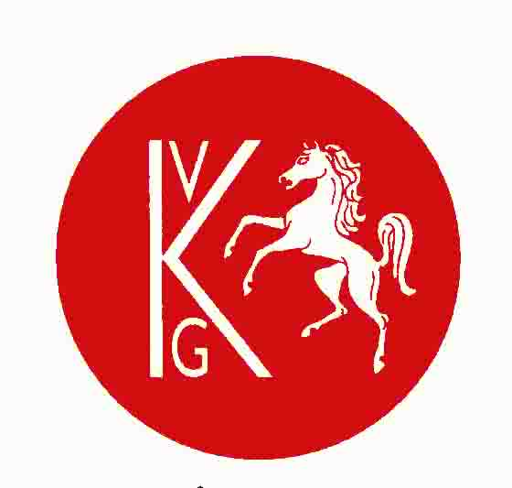
email:ellisparker632@btinternet.com
Founder:
Gordon Emerton-Court

President:Dave Parker MBEHon. Secretary: Dr. Nigel Courtney

Derek Ruthven Trophy
at Chestfield Golf Club 103 Chestfield Road,Whitstable Kent CT5 3LU
Singles competition on Friday16thJune2023

Founded in 1924and is there a more beautiful clubhouse in the world. Certainly there are few older. It dates from the 15th century.
The course has been updated by Donald Steel. While the 1st and 18th are the most attractive holes,the most challenging are on ShrubHill, especially the 552yd 2nd.
We will play a Singles Stableford competition over 18 holes, starting from the 1st and 13thYellow Teesat 8 minute intervals from 08.30.Handicap Allowance will be 90% of Course Handicap.In the event of the event being over-subscribed a ballot will take place.At present we are told only 100 can play.
Would AKVG members who wish to play in this competition please contact your AKVG Rep with yournameand any buggy or dietary requirements. If a new member, then we will require your CDH number and the £3 membership fee added to your match fee.
The club has 5double buggies at a cost of £25 payment at the pro shop.. All five have been reservedfor AKVG. Players may have to share with a player from a different club.
Now that England Golf has granted AKVG ‘Approved Tournament Organizer’ status we are able to enter members’ scorecardsdirectly to the WHS.
Note to all members: at the AGM last November we announced that because of steeply-rising booking costs at venues the match fee for 2023 events would have to be increased to £49pp. However, in view of current cost of living increasesyour committee resolved on the 25th January 2023 to keep the match fee at the 2022 levelby means of a subsidy from AKVG reserves.
As a result the match fee for all our 2023 events will now be £47pp.
So thematch fee will be £47 per person, (Chestfieldmembers £20) toinclude tea/coffee on arrival, golf, lunch, prizes and charitable donations to the Kent, Surrey & Sussex Air Ambulance Trust and to the Captain’s charity: St Christopher’s Hospice.
Dress code for the lunch is Jacket &(club) tie OR smart casual (which doesnot include golfing attire).
Entries are payable to your AKVG Representative (please check with him how he wants payment) byFriday 9thJunewhich is the cut-off date for entries.The final order of play will be submitted to the scorer on the 13th so that cards can be marked up with name and handicap.

